BIBLE STUDY



WHEN: FRIDAY NIGHTS 7-9PM (OR WHEN YOU ARE AVAILABLE)
WHERE: FRONT LOBBY, YOUR APARTMENT, MINE 709 OR COMMUNITY ROOM.
WHY: TO DRAW NEAR TO GOD, TO TALK ABOUT GOD, TO KNOW YOUR SAVIOR…
WHO: ANYONE INTERESTED
CONTACT: KEVIN DUCLAIRON (BIBLE PREACHER IN PORTLAND)
HOW: I CAN BE REACHED BY
- EMAIL kevinluke02@hotmail.com,
- NOTES TAPED TO MY DOOR, OR SLIPPED UNDER THE DOOR OF APT. 709.
- TALK TO ME WHEN YOU SEE ME IN THE LOBBY.
GOAL: FOR YOU TO GAIN BIBLE KNOWLEDGE AND BECOME A DISCIPLE OF JESUS.

HOW WOULD YOU LIKE TO BECOME A DISCIPLE OF THE LORD JESUS CHRIST?
JOHN 3

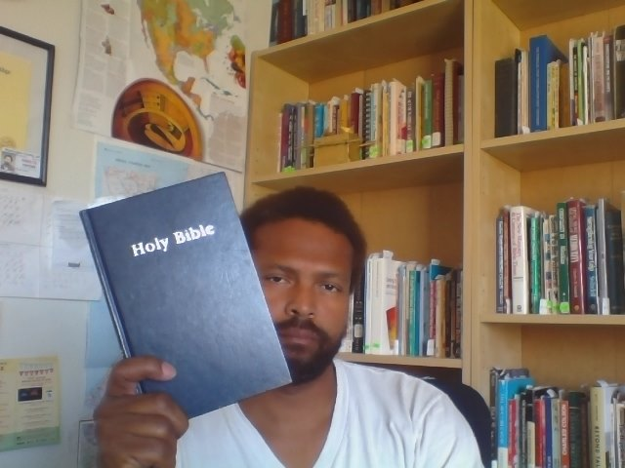
The Church of Portland (The Church At Seattle/Grace Gospel Faith International Church Fellowship)
Walk With God Ministries Press Publishing Distribution
Kevin Ernst Duclairon – Preacher – Evangelist
P.O. Box 3322,
Portland, Oregon 97208
Kevinluke02@hotmail.com
Copyright @ 2015
KEVIN DUCLAIRON’S PRAYER REQUEST

CHURCH PLEASE PRAY FOR MY ATTEMPT TO START A BIBLE STUDY IN MY APARTMENT ON FRIDAY NIGHTS.
THANK YOU

