
DUCLAIRON MINISTRIES: THE CHURCH OF PORTLAND

ANYTIME PRAYER MEETINGS

CHURCH, IF YOU SEE ME ASK ME, I WILL PRAY WITH YOU OR FOR YOU.

7:00 PM – FRIDAY NIGHT BIBLE STUDY

“BE DILIGENT TO PRESENT YOURSELF APPROVED TO GOD AS A WORKMAN WHO DOES NOT NEED TO BE ASHAMED, ACCURATELY HANDLING THE WORD OF TRUTH.” 2 TIM. 2:15

9:00 AM – SUNDAY MORNING MEETING

“NOT FORSAKING OUR OWN ASSEMBLING TOGETHER, AS IS THE HABIT OF SOME, BUT ENCOURAGING ONE ANOTHER; AND ALL THE MORE AS YOU SEE THE DAY DRAWING NEAR.” HEB. 10:25

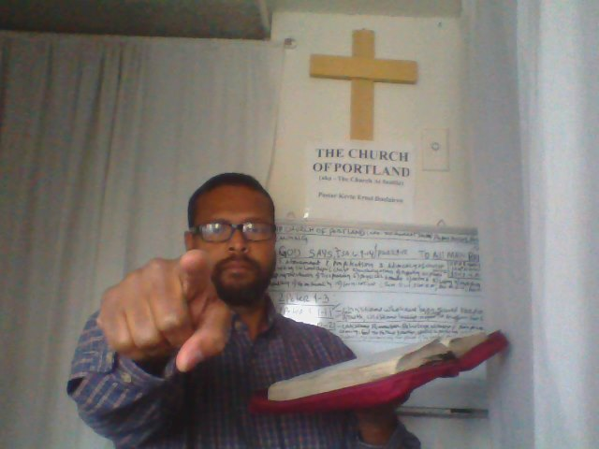
DUCLAIRON MINISTRIES 2017
THE CHURCH OF PORTLAND (aka – The Church At Seattle)
Walk With God Ministries Press Publishing Distribution
P.O. BOX 3322, PORTLAND, OR. 97208
Kevinluke02@hotmail.com - Copyright @ 2017

